# **Introduction**

Academic writing is writing which communicates information, ideas, and research to the wider academic community. But it is not personal, complicated, or long-winded. It is also not journalistic, literary, or marketing text. It is formal and unbiased, clear and precise, focused and well structured, well-sourced, correct, and consistent (Scribbr, 2022). It follows some rules and regulations. Its main focus is to make the readers understand what they are reading with the formal, objective, and concise language. Essay, lab report, research proposal, annotated bibliography, literature review, and thesis/dissertation falls under the four different types of academic writing which are descriptive, analytical, critical, and persuasive. Every writing type has its language features and purposes (University, 2021).

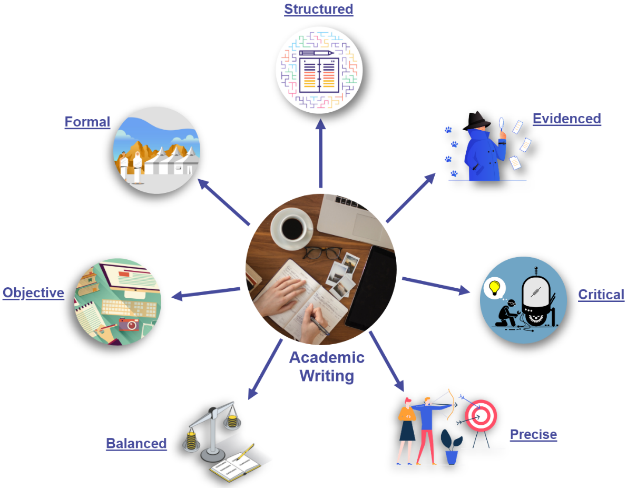

Figure 1: Academic Writing

Academic writing has a clear structure that provides sense. Opinions and arguments are supported by evidence (facts, reasons, examples, statistics, citations). In the same way, Information is analyzed and evaluated in academic writing. Languages used in academic writing are clear and precise too. Academic writing considers all sides of the issue and avoids bias. Emphasis is placed on the arguments and information, rather than on the writer. Similarly, Passive and impersonal structures are used in academic writing. It does not use complicated vocabulary and long sentences (EAPFoundation.com, 2021).

# **Coursework and Dissertation**

According to the Oxford dictionary, “Coursework” is defined as the practical/written work given to the students while studying a course that has to be completed within a given period so that they can score good grades in their course. On the other hand, A dissertation is research done on a specific topic over a long period to achieve some solutions to a problem or to discover something new and useful (Collier, 2022). Coursework can vary from long essays, app design, fieldwork, and projects, to programming. The coursework is assigned by the lecturers of the course to determine how well the students understand the course and can use the knowledge of their course in different situations. Talent, understanding, creativity, and innovative aspect will be reflected in the coursework done by the students. The reaction of the students varies from each other when they are given the coursework. Some find it exciting because it gives them an option to present their viewpoint but some find it boring and do not want to do it. But following some rules and guidelines while completing coursework will make it easy to go through (Admin, 2017). Conversely, only a little guidance will be provided by the tutors but all the research has to be done from scratch on your own while writing the dissertation. It requires lots of hard work, months of preparation, and patients to complete it. Some may also face frustration while completing it. It can be the most important, longest, and most difficult assignment done by the students at university. It also might be very rewarding for some of the students. It is better to choose an interesting topic for the dissertation so that the students will never lose energy and interest while completing it (Collier, 2022).

Some students consider coursework as a home-based exam. Some students are terrible at taking exams. They underperform in it and some fail it even though they have a good knowledge of the course. Therefore, some also think that coursework is invented to help the students who cannot do well in the exam. Coursework has shown a little fairer to those students. Most of the students prefer taking some number of coursework instead of taking the exam. Coursework has decreased the stress of the exam among the students (PaperWritingPro, 2019). Attending every class, practicing, and completing the tasks given by the teacher might help a lot to produce good coursework. Students also have to think about plagiarism, and word count while writing the coursework. Choosing a unique topic than others and asking the teacher for their guidance on what to write or for any confusion will result in a good final grade. However, the word count in a dissertation varies according to the study level and country. 10,000-12,000 for undergraduate, 15,000-25,000 for master, and up to 50,000 or more for Ph.D. level. A dissertation might be empirical or non-empirical. Empirical dissertations involve data collection. Data are collected from the public. Science subjects will involve laboratory work too. Those dissertations which are based on other works like arguments or existing data are known as non-empirical dissertations. A significant amount of time is needed while researching from different sources like books, articles, and research papers. They don’t just have to describe others’ works but also have to critically analyze the works. They have to explore practical applications in non-empirical dissertations. A dissertation’s type varies with the type of course that the student studies (Collier, 2022). The basic goal of a dissertation is to uncover answers, although not every dissertation will yield the correct answers or will end with a partial solution. Even though the research in a dissertation is not completed that does not make the dissertation wrong or bad. A good dissertation follows a well-structured process, provides critical analysis, lots of arguments, and well confession for not answering some of the questions if the research is incomplete (Hull, 2022).

## **Similarities**

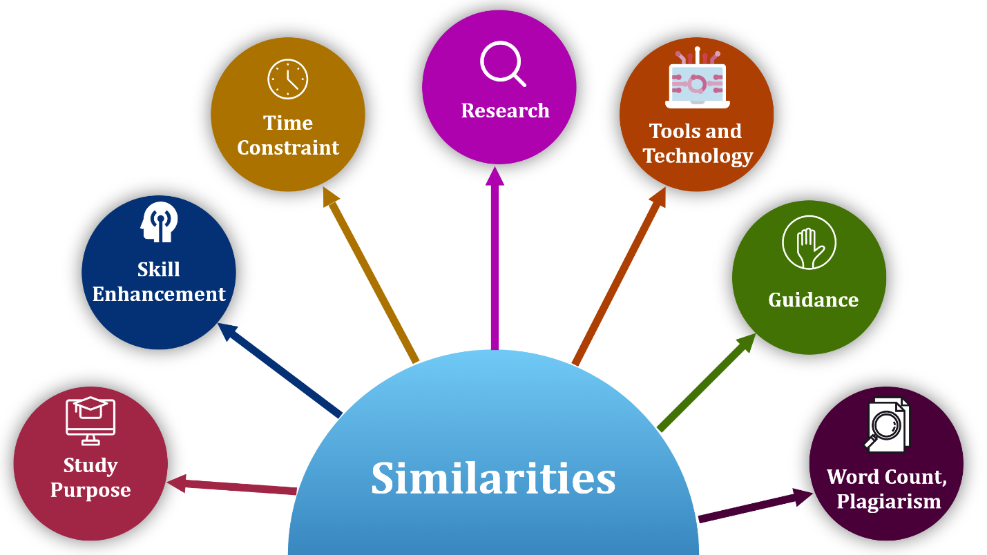

Figure 3: Similarities between coursework and dissertation

Both coursework and dissertation fall under academic writing. The main purpose of both coursework and dissertation is to gain a good final grade in a course or to achieve a degree in a specific field. Both follow the same language, style, tone, grammar, and document formats. Similarly, both increase students’ capabilities of thinking critically, researching, creativity, innovation, communication, sharing ideas, and time management because lots of time are needed to find the perfect solution. Therefore, students get a chance to enhance their skills and improve themselves over time. Both writings have to be completed within a certain time otherwise they might fail. Both require researching to answer questions, learn new things, and clear confusion. However, the time and amount of research might vary but without research, both cannot be completed. Students can use any kind of research materials. Empirical materials involve journals, books, articles, and research papers that gives already collected data and lots of information. Most of the students go through the internet sources like online libraries, encyclopedias, and websites because it saves time. However, there is not much difference in what kind of tools and technology have to be used while writing coursework or dissertation, for example, documentation with MS word, making infographics with Adobe XD or MS Visio, etc. Both writings require guidance from the teacher at some level. Some might require a little or more also. Students can ask for help from the teachers anytime while writing it. Likewise, they can review it, and get feedback at any time. This will improve their writing. Both writings have word count limits as well as plagiarism checking. If the word count of the writing is not within the limits of their writing, or get lots of plagiarism, then students might score low in their final grade. Therefore, word count and plagiarism are important things to consider in both coursework and dissertation otherwise no matter how good the contents are, students might not get the right marks (Schoolworkspro, 2022).

## **Differences**

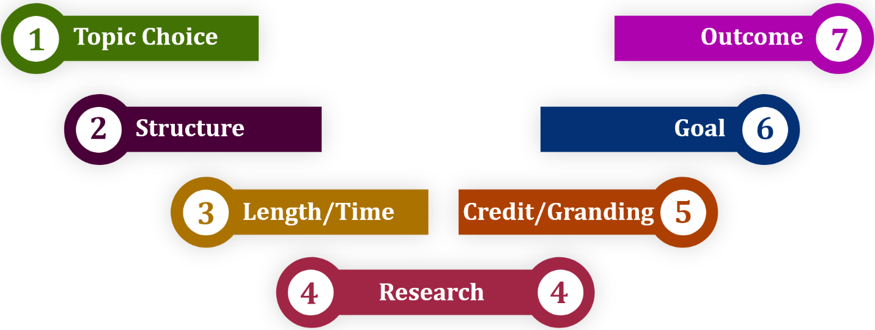

Figure 4: Differentiating terms between coursework and dissertation

The topic for the coursework is often provided by the teachers or some questions to find the solution. On the other hand, students have to choose a topic of their interest themselves and the research questions have to raise on their own to set out the research. Coursework will show how well did the students understand the course and some creativity and innovation skills whereas the dissertation will enhance the skill of researching, discovering new things, critical analysis, data collection, exploring practical applications, etc. The coursework structure is already defined in the course whereas the dissertation does not have a particular structure. The length of the dissertation is very long compared to the coursework. The word count of the coursework is very less compared to the dissertation. The writing period of the dissertation is very long and could take more than one semester but the coursework is finished before the semester is completed. A little research can be enough for a coursework to be finished. On the contrary, a dissertation requires a month of preparation, hard work, and lots of research on a particular topic. A dissertation carries more credit than coursework. The coursework has already predefined guidelines and marking schemas and based upon this, students get marks. On the other hand, a dissertation does not have fixed marking schemas or guidelines. Students are free to research anything related to the topic and can add an extra element to the writing. Therefore, based on the dedication to research, quality of researched content, critical analysis, understanding, originality, and presentation of information, students are given marks. A dissertation is done to get a degree in the university whereas coursework is completed to pass a single course. A coursework outcome is already defined but the outcome of a dissertation is unknown. The dissertation outcome might be different from the student’s expectation or might be more valuable but it is unclear at first (Schoolworkspro, 2022).

# **Writing Process**

## **Coursework**

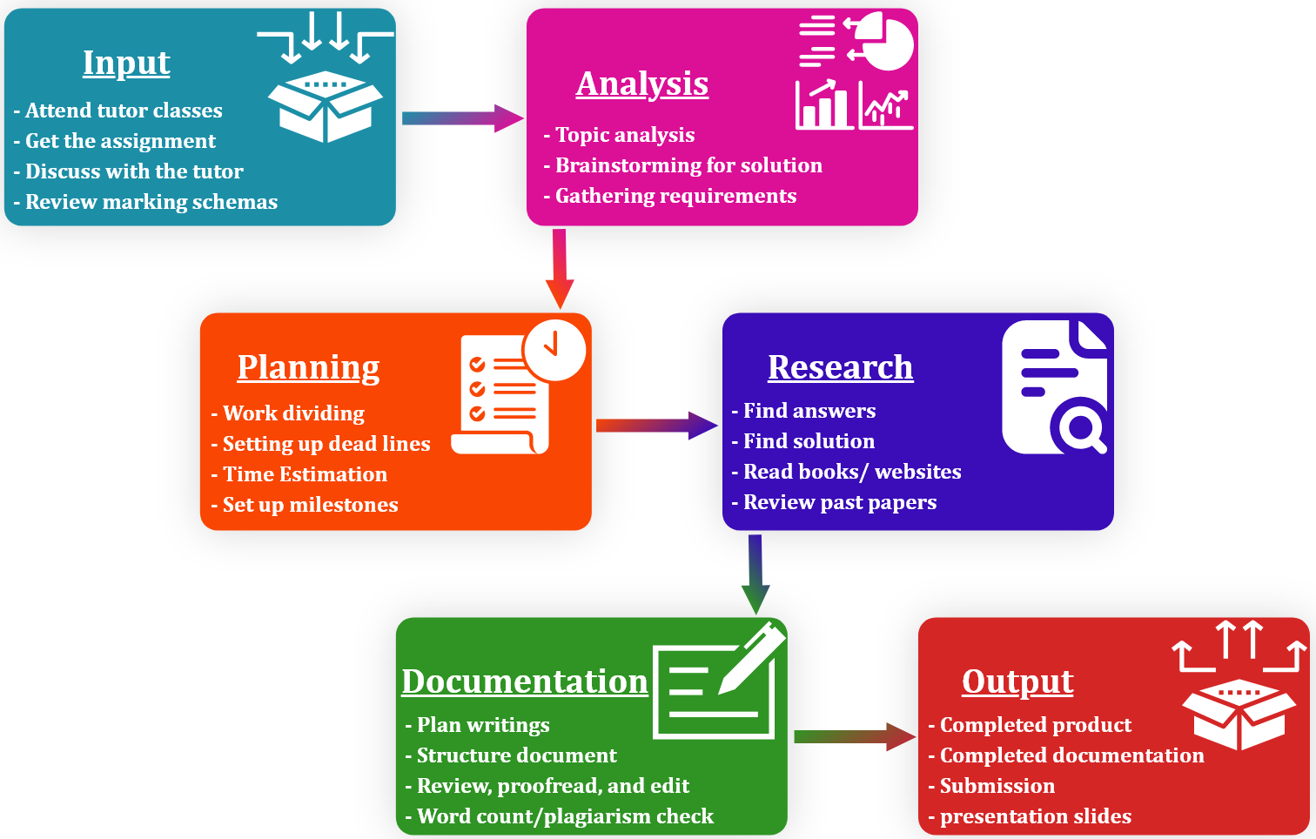

Figure 5: Writing process of coursework

The writing process of coursework is a bit easier in contrast to the dissertation. It is also because students can get help from the tutors frequently whenever they want, they can follow the predefined structure, and marking schemas, and they can easily find the solution for the coursework. However, students have to attend the classes given by the tutors. After they are given the assignment, they need to understand the assignment brief. They can discuss this with their tutor to clear their confusion. Similarly, they can review the marking schemas. Then, they have to choose a good topic if the topic is not given. They need to spend some time brainstorming for the right solution and gather all the requirements to complete the assignment perfectly. Before writing the coursework, it is better to plan it. Diving the whole assignment into multiple works and setting up a deadline for each work will be very beneficial for managing time, and completing the assignment before the submission deadline. Furthermore, students need to do some research like finding answers, and solutions, reading books, journals, and websites, and reviewing past papers. They have to plan the writings of their researched information. Moreover, they have to write the document in a structure and be careful about the word count and plagiarism. At last, they need to review, proofread, and edit their document, and get feedback from the tutor. After then, the product or document will be completed which will be submitted. There will be also presentation slides if needed (Admin, 2017) (Vainer, 2019).

## **Dissertation**

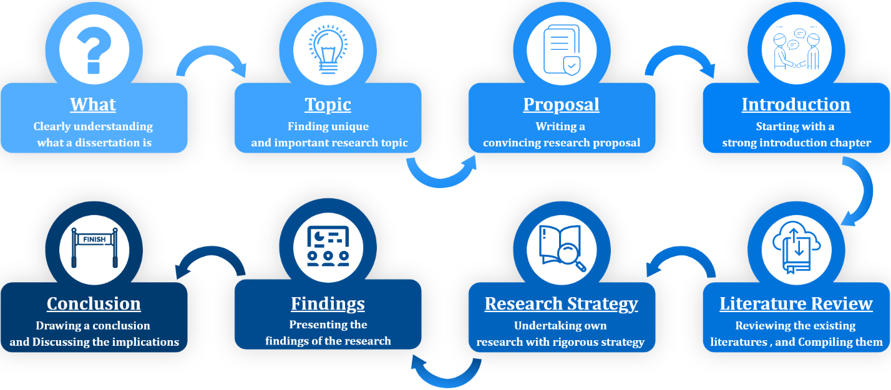

Figure 6: Dissertation Writing Process

A dissertation is not an easy task. It requires a great deal of effort, attention, and patience. Before diving into it, students should have a clear understanding of what is a dissertation and how it is done, how it looks. Similarly, while choosing a topic, students have to spend some time brainstorming for a clear, unique, and important research topic. After reading the topic, the tutor should know what is the student plan to research, it should be based on a question that is never been asked before and the question should create value. Then, a convincing research proposal needed to be submitted to the university to show that the research topic is worthy enough to conduct research. Students can start writing the dissertation once their topic has been approved. If the students have crafted a high-quality proposal, then they don’t have a hard time starting the introduction, literature review, and methodology. In the same way, students have to introduce the dissertation with a brief background, problem statement, research questions, and significance of the research. Then, students have to go through existing literature like journals, books, report papers, etc. to understand what has been already researched about the topic. Similarly, students write up a literature review chapter that synthesis the existing research, highlights a research gap, and inform the methodology. Moreover, students also need to conduct their research to answer research topic unique questions. Students have to design their research strategy and execute and analyze the collected data. After then, students present their findings in the results chapter which presents statistical tests of the results, and a discussion chapter that will explain what the data are telling. At last, students complete the dissertation with a conclusion that highlights the key findings during the research and elaborates the implications of the findings. (Jansen, 2020).

# **Benefits**



Figure 7: Benefits of coursework and dissertation writing

The main benefit of writing coursework or a dissertation is that students will gain knowledge and develop lots of skills. They will be better at reading, understanding, and writing. In the same way, they will critically think about a problem to find a solution. They will enhance problem-solving, communication, creativity, innovation, and research skill. The dissertation will increase researching, and analyzing skills more than coursework. Students will be better at saving time, completing work before the deadline, managing and controlling their, and working on the deadline. Likewise, students will get the confidence to take on the challenges when they finish their work. Good coursework or dissertation will provide a better grade that will give students satisfaction, and good feelings, and keep their interest high (Achievers, 2021) (Wanic, 2015). Students will get success or pass a single module after completing the coursework whereas a dissertation will give the students a university degree. A dissertation will be very helpful for a better career and give long-term achievement. Coursework will be also helpful to get success in a particular field like getting a job.

# **Challenges**

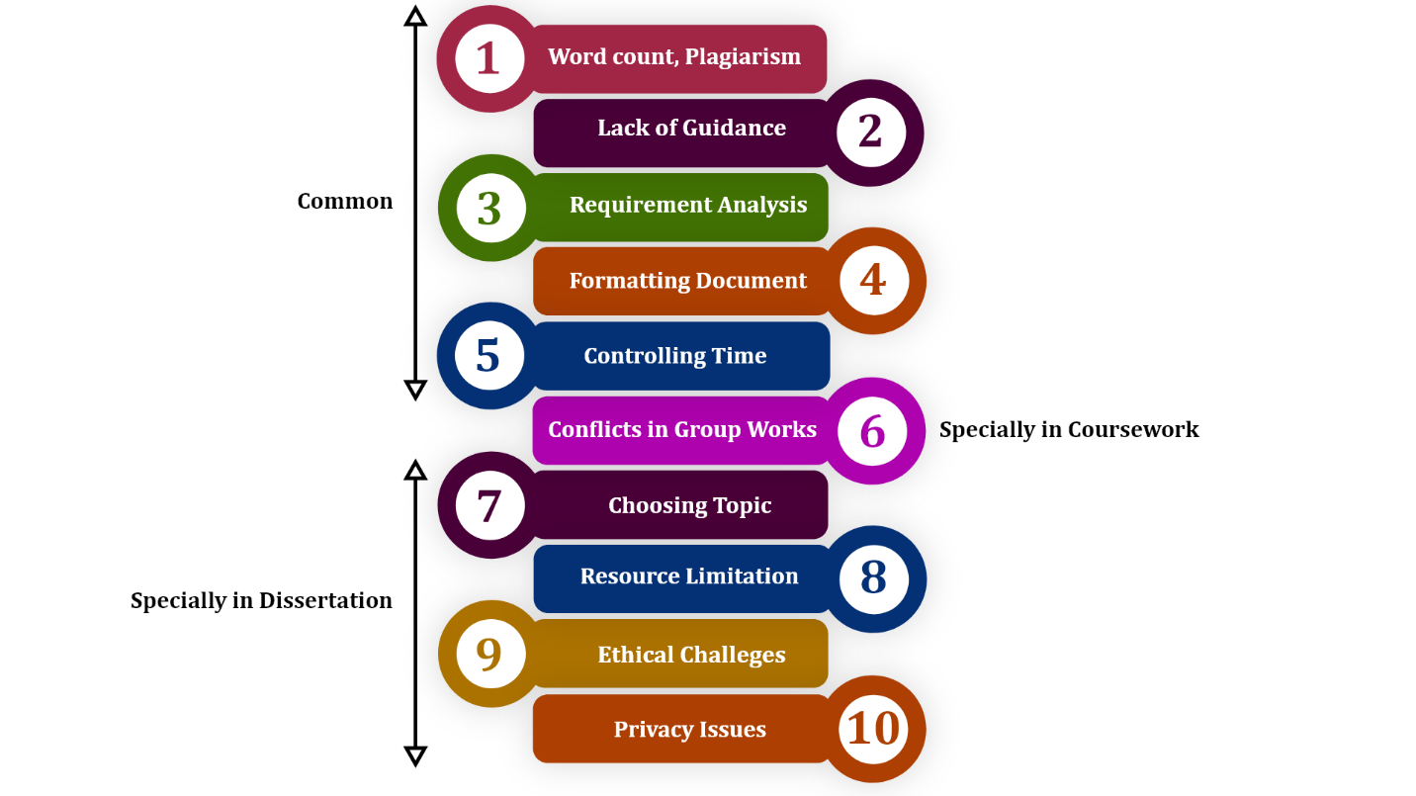

Figure 8: Challenges faced while writing coursework and dissertation

Writing a dissertation is way more challenging than writing coursework. Some coursework challenges might be similar to the dissertation. Students have to write under the limitation of word count and the writing should be free of plagiarism. However, plagiarism is found in most students’ writing. During the writing process, most of the students cannot manage their time and they had completed only some part of their coursework even though the deadline is near. Most of the students cannot work under deadlines. Some students ask their tutors for help frequently whereas some don’t care about it and they did not know what exactly should be done in their writing. Because of this, some students do not understand the requirement properly too. On other hand, the teacher also might not be available for guidance in some cases. Therefore, getting frequent helps from the lecturer might not be possible (Writing, 2018). Likewise, a common problem is documenting properly. The student’s work might not be in the correct format or structure. The language, grammar, and tone used in the document might not be satisfying for the tutor. In most group projects, there is a high risk of disagreement, so strong collaboration is essential. The first challenge faced by the students while writing a dissertation is choosing a clear, unique, and valuable topic. Even though the topic is approved by the university to start the research, students might have a really hard time finding enough resources like books, journals, and research papers to support the research topic. In the same way, wrapping the researched resources into single new information is also not easy (Burgess, 2022). Furthermore, Students have to write a dissertation considering the privacy issues and ethical challenges. Analyzing the collected data and presenting it in the research papers might be harmful to others.

# **Conclusion**

Academic writing differs from personal writing. It is structured, clear, evidenced, focused, and concise. Even though coursework and dissertation both are academic writing, they are different from each other in some manners. A dissertation is longer than coursework and takes lots of hard work and time to finish. A dissertation gives long-term achievement. Coursework questions and outcomes are predefined whereas it is unclear and needs to be researched a lot more in the dissertation. Both coursework and dissertation are completed to get success in the educational field. Similarly, both enhance students’ skills. Lots of challenges are faced by the students while writing coursework and dissertation and writing a dissertation is way harder than coursework. But completing both perfectly leads to great achievement and provides better career opportunities.